Secure crypto-biometric system for cloud computing
1. INTRODUCTION:
Cloud computing is a trend in application architecture and development, as well as a new business model. The success of many service providers, with Amazon as a remarkable example, has demonstrated that the model can be applied to a wide variety of solutions, covering the different levels defined in the cloud paradigm (SaaS, PaaS and IaaS). We can consider that cloud computing is at a mature stage, although there remain some limitations and challenges. Cloud computing brings important benefits for organizations that outsource data, applications, and infrastructure, at the cost of delegating data control. The information is processed in computers that the users do not own, operate, or manage. In this scenario, the user does not know how the provider handles the information, and therefore a high level of trust is needed. The lack of control over physical and logical aspects of the system imposes profound changes in security and privacy procedures. Currently there is even a lack of service level agreements between providers and users regarding security. Our research focuses on adequate security mechanisms that should potentially meet the legal requirements of traditional systems. In recent years, intense research work has been devoted to biometrics, and their applications to security have become more evident. The combination of cloud computing and biometric technology opens new research and implementation opportunities to protect user data in the cloud. However, biometric templates must remain secure even for cloud services providers given the privacy-sensitive nature of biometric data. This requisite is more important than in the case of alphanumerical passwords due to the impossibility of changing user information in the same way.
1.1 Objective of the project:
Cloud computing has achieved maturity, and there is a heterogeneous group of providers and cloud-based services. However, significant attention remains focused on security concerns. In many cases, security and privacy issues are a significant barrier to user acceptance of cloud computing systems and the advantages these offer with respect to previous systems. Biometric technologies are becoming the key aspect of a wide range of secure identification and personal verification solutions, but in a cloud computing environment they present some problems related to the management of biometric data, due to privacy regulations and the need to trust cloud providers. To overcome those problems in this paper, we propose a crypto biometric system applied to cloud computing in which no private biometric data are exposed.
2. LITERATURE SURVEY:
outsourcing computation without outsourcing control.:
Cloud computing is clearly one of today's most enticing technology areas due, at least in part, to its cost-efficiency and flexibility. However, despite the surge in activity and interest, there are significant, persistent concerns about cloud computing that are impeding momentum and will eventually compromise the vision of cloud computing as a new IT procurement model. In this paper, we characterize the problems and their impact on adoption. In addition, and equally importantly, we describe how the combination of existing research thrusts has the potential to alleviate many of the concerns impeding adoption. In particular, we argue that with continued research advances in trusted computing and computation-supporting encryption, life in the cloud can be advantageous from a business intelligence standpoint over the isolated alternative that is more common today.
Achieving Secure, Scalable, and Fine-Grained Data Access Control in Cloud Computing:
Cloud computing is an emerging computing paradigm in which resources of the computing infrastructure are provided as services over the Internet. As promising as it is, this paradigm also brings forth many new challenges for data security and access control when users outsource sensitive data for sharing on cloud servers, which are not within the same trusted domain as data owners. To keep sensitive user data confidential against untrusted servers, existing solutions usually apply cryptographic methods by disclosing data decryption keys only to authorized users. However, in doing so, these solutions inevitably introduce a heavy computation overhead on the data owner for key distribution and data management when fine-grained data access control is desired, and thus do not scale well. The problem of simultaneously achieving fine-grainedness, scalability, and data confidentiality of access control actually still remains unresolved. This paper addresses this challenging open issue by, on one hand, defining and enforcing access policies based on data attributes, and, on the other hand, allowing the data owner to delegate most of the computation tasks involved in fine-grained data access control to untrusted cloud servers without disclosing the underlying data contents. We achieve this goal by exploiting and uniquely combining techniques of attribute-based encryption (ABE), proxy re-encryption, and lazy re-encryption. Our proposed scheme also has salient properties of user access privilege confidentiality and user secret key accountability. Extensive analysis shows that our proposed scheme is highly efficient and provably secure under existing security models.
Ensuring data storage security in Cloud Computing:
Cloud computing has been envisioned as the next-generation architecture of IT enterprise. In contrast to traditional solutions, where the IT services are under proper physical, logical and personnel controls, cloud computing moves the application software and databases to the large data centers, where the management of the data and services may not be fully trustworthy. This unique attribute, however, poses many new security challenges which have not been well understood. In this article, we focus on cloud data storage security, which has always been an important aspect of quality of service. To ensure the correctness of users' data in the cloud, we propose an effective and flexible distributed scheme with two salient features, opposing to its predecessors. By utilizing the homomorphic token with distributed verification of erasure-coded data, our scheme achieves the integration of storage correctness insurance and data error localization, i.e., the identification of misbehaving server (s). Unlike most prior works, the new scheme further supports secure and efficient dynamic operations on data blocks, including: data update, delete and append. Extensive security and performance analysis shows that the proposed scheme is highly efficient and resilient against Byzantine failure, malicious data modification attack, and even server colluding attacks.
Data ProtectionAware Design for Cloud Services. Proceedings of the 1st International Conference on Cloud Computing:
The Cloud is a relatively new concept and so it is unsurprising that the information assurance, data protection, network security and privacy concerns have yet to be fully addressed. This paper seeks to begin the process of designing data protection controls into clouds from the outset so as to avoid the costs associated with bolting on security as an afterthought. Our approach is firstly to consider cloud maturity from an enterprise level perspective, describing a novel capability maturity model. We use this model to explore privacy controls within an enterprise cloud deployment, and explore where there may be opportunities to design in data protection controls as exploitation of the Cloud matures. We demonstrate how we might enable such controls via the use of design patterns. Finally, we consider how Service Level Agreements (SLAs) might be used to ensure that third party suppliers act in support of such controls.
Enabling Public Verifiability and Data Dynamics for Storage Security in Cloud Computing:
. Cloud Computing has been envisioned as the next-generation architecture of IT Enterprise. It moves the application software and databases to the centralized large data centers, where the management of the data and services may not be fully trustworthy. This unique paradigm brings about many new security challenges, which have not been well understood. This work studies the problem of ensuring the integrity of data storage in Cloud Computing. In particular, we consider the task of allowing a third party auditor (TPA), on behalf of the cloud client, to verify the integrity of the dynamic data stored in the cloud. The introduction of TPA eliminates the involvement of client through the auditing of whether his data stored in the cloud is indeed intact, which can be important in achieving economies of scale for Cloud Computing. The support for data dynamics via the most general forms of data operation, such as block modification, insertion and deletion, is also a significant step toward practicality, since services in Cloud Computing are not limited to archive or backup data only. While prior works on ensuring remote data integrity often lacks the support of either public verifiability or dynamic data operations, this paper achieves both. We first identify the difficulties and potential security problems of direct extensions with fully dynamic data updates from prior works and then show how to construct an elegant verification scheme for seamless integration of these two salient features in our protocol design. In particular, to achieve efficient data dynamics, we improve the Proof of Retrievability model [1] by manipulating the classic Merkle Hash Tree (MHT) construction for block tag authentication. Extensive security and performance analysis show that the proposed scheme is highly efficient and provably secure.
Privacy protecting biometric authentication systems:
In this paper we present a short overview of results that have been achieved on template protecting biometric authentication systems.
Cloud Software as a Service with Iris Authentication:
Cloud computing provides amble opportunity in many areas. In our Cloud Data Server provides fast and reliable software service to its clients.In that service authentication for identifying authorized user as a major issue. So we proposed a novel security mechanism named as iris cloud verification. The Cloud Iris Verification System(CIVS) enables authorized user to access software as a service from cloud server. It is suggested in recent biometric literature that human irises might be as distinct as fingerprints for different individuals, leading to the idea that iris patterns may contain unique identification features. An CIVS compares a newly acquired iris pattern with a retrieved iris pattern from a data base to decide if they originated from the same eye. Iris patterns are collected from images of the eye. Our system proposes novel and efficient cloud iris recognition method that employs cumulative SUM based grey change analysis. Iris recognition includes security to cloud server from unauthorized access. We demonstrate the effectiveness and feasibility of our method on a thousands of eye images for defense forces. The efficiency ratio of this computation process is 93.17.
Tongue as a Biometric Visualizes New Prospects of Cloud Computing,:
Cloud computing is the need of changing network trends. It is based on the distributed computation in which the operations are carried out on the unfixed nodes. As all the nodes are not trusted so when the operations are applied on those nodes it hampers the users privacy information. So, in order to give it a secure environment we introduce tongue as a biometric to resolve the security issues of cloud computing. In this paper we are focusing on the method that has three parts:- user part provides tongue images; cloud initialization part has a tongue subspace and template database, cloud private matching identification part contains the core algorithm of the method which compares two encrypted numbers under double encrypted conditions. The algorithm ensures to make users tongue data secure and to develop a credible, efficient low complex method to guarantee cloud computing security.
Enhancing Security and Privacy of Biometric-Based Authentication Systems:
Because biometrics-based authentication offers several advantages over other authentication methods, there has been a significant surge in the use of biometrics for user authentication in recent years. It is important that such biometrics-based authentication systems be designed to withstand attacks when employed in security-critical applications, especially in unattended remote applications such as e-commerce. In this paper we outline the inherent strengths of biometrics-based authentication, identify the weak links in systems employing biometrics-based authentication, and present new solutions for eliminating some of these weak links. Although, for illustration purposes, fingerprint authentication is used throughout, our analysis extends to other biometrics-based methods.
3. SYSTEM ANALYSIS
3.1 EXISTING SYSTEM:
In existing system,intense research work has been devoted to biometrics, and their applications to security have become more evident. The combination of cloud computing and biometric technology opens new research and implementation opportunities to protect user data in the cloud. The weaknesses that may result from this complexity are still unclear. Different solutions can be found depending on the subsystem to protect. These issues are considered in “Cloud Security Issues” which also defines an SLA to describe different levels of security.
DISADVANTAGES:
- Biometric templates must remain secure even for cloud services .
- Cost
- Significant investment needed in biometrics for security.
- Biometric databases can still be hacked.

3.2 PROPOSEDSYSTEM :
We have proposed a method that allows a verifier to check the authenticity of the user, in a way that prevents the verifier from learning any information about the biometrics of the user. This schema is suitable for third-party cloud applications to provide security. A training system has been proposed to increase the models of the schema, improving security. This training system uses cloud resources to perform computationally intensive tasks efficiently. Authentication relies on a classic public and private key mechanism. This allows the system to take advantage of all the infrastructures based on certification authorities and the solutions based on that type of cryptography. We have proposed a feasible secure cryptographic system that is oriented to critical data in cloud environments. Biometric identification provides accurate, secure access to the information. A major difference between our model and other biometric schemas is that ours ensures that the cloud knows neither user biometric data nor the result of the biometric private matching identification. The lack of a direct matching process in our model enforces its security and makes it better conditioned for law compliance. We have proposed a method that allows a verifier to check the authenticity of the user, in a way that prevents the verifier from learning any information about the biometrics of the user. This schema is suitable for third-party cloud applications to provide security. A training system has been proposed to increase the models of the schema, improving security. This training system uses cloud resources to perform computationally intensive tasks efficiently.

ADVANTAGES:
- This allows the system to take advantage of all the infrastructures based on certification authorities and the solutions based on that type of cryptography.
- provides a secure and uncrackable access control solution
Modules Information:
To implement this project author has designed following modules
- Upload Biometric Database: using this module we will upload biometric templates database to application
- Run Features Extraction: using this module we will extract features from templates
- Run Features Selection & BCH Encoder: in this module using PCA we will select features and then encode the features
- Encoder Training using GMM & Key: encoded features will key get trained with GMM
- BCH Decoder Verification: using this module we will upload test image and then decode and perform verification
3.3. PROCESS MODEL USED WITH JUSTIFICATION
SDLC (Umbrella Model):
Umbrella Activity
Umbrella Activity
Umbrella Activity
- Feasibility Study
- TEAM FORMATION
- Project Specification PREPARATION

Business Requirement Documentation
ANALYSIS & DESIGN
CODE
UNIT TEST
DOCUMENT CONTROL

ASSESSMENT

TRAINING
INTEGRATION & SYSTEM TESTING

DELIVERY/INSTALLATION
ACCEPTANCE TEST
Requirements Gathering
SDLC is nothing but Software Development Life Cycle. It is a standard which is used by software industry to develop good software.
Stages in SDLC:
- Requirement Gathering
- Analysis
- Designing
- Coding
- Testing
- Maintenance

Requirements Gathering stage:
The requirements gathering process takes as its input the goals identified in the high-level requirements section of the project plan. Each goal will be refined into a set of one or more requirements. These requirements define the major functions of the intended application, define operational data areas and reference data areas, and define the initial data entities. Major functions include critical processes to be managed, as well as mission critical inputs, outputs and reports. A user class hierarchy is developed and associated with these major functions, data areas, and data entities. Each of these definitions is termed a Requirement. Requirements are identified by unique requirement identifiers and, at minimum, contain a requirement title and textual description.
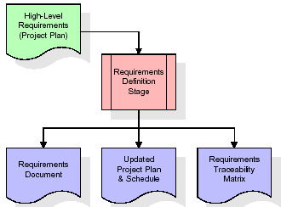
These requirements are fully described in the primary deliverables for this stage: the Requirements Document and the Requirements Traceability Matrix (RTM). The requirements document contains complete descriptions of each requirement, including diagrams and references to external documents as necessary. Note that detailed listings of database tables and fields are not included in the requirements document.
The title of each requirement is also placed into the first version of the RTM, along with the title of each goal from the project plan. The purpose of the RTM is to show that the product components developed during each stage of the software development lifecycle are formally connected to the components developed in prior stages.
In the requirements stage, the RTM consists of a list of high-level requirements, or goals, by title, with a listing of associated requirements for each goal, listed by requirement title. In this hierarchical listing, the RTM shows that each requirement developed during this stage is formally linked to a specific product goal. In this format, each requirement can be traced to a specific product goal, hence the term requirements traceability.
The outputs of the requirements definition stage include the requirements document, the RTM, and an updated project plan.
- Feasibility study is all about identification of problems in a project.
- No. of staff required to handle a project is represented as Team Formation, in this case only modules are individual tasks will be assigned to employees who are working for that project.
- Project Specifications are all about representing of various possible inputs submitting to the server and corresponding outputs along with reports maintained by administrator.
Analysis Stage:
The planning stage establishes a bird's eye view of the intended software product, and uses this to establish the basic project structure, evaluate feasibility and risks associated with the project, and describe appropriate management and technical approaches.
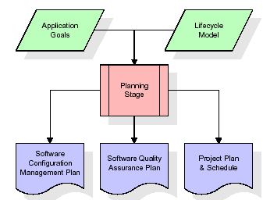
The most critical section of the project plan is a listing of high-level product requirements, also referred to as goals. All of the software product requirements to be developed during the requirements definition stage flow from one or more of these goals. The minimum information for each goal consists of a title and textual description, although additional information and references to external documents may be included. The outputs of the project planning stage are the configuration management plan, the quality assurance plan, and the project plan and schedule, with a detailed listing of scheduled activities for the upcoming Requirements stage, and high level estimates of effort for the out stages.

Designing Stage:
The design stage takes as its initial input the requirements identified in the approved requirements document. For each requirement, a set of one or more design elements will be produced as a result of interviews, workshops, and/or prototype efforts. Design elements describe the desired software features in detail, and generally include functional hierarchy diagrams, screen layout diagrams, tables of business rules, business process diagrams, pseudo code, and a complete entity-relationship diagram with a full data dictionary. These design elements are intended to describe the software in sufficient detail that skilled programmers may develop the software with minimal additional input.
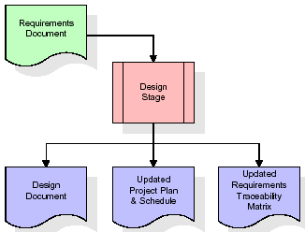
When the design document is finalized and accepted, the RTM is updated to show that each design element is formally associated with a specific requirement. The outputs of the design stage are the design document, an updated RTM, and an updated project plan.
Development (Coding) Stage:
The development stage takes as its primary input the design elements described in the approved design document. For each design element, a set of one or more software artifacts will be produced. Software artifacts include but are not limited to menus, dialogs, and data management forms, data reporting formats, and specialized procedures and functions. Appropriate test cases will be developed for each set of functionally related software artifacts, and an online help system will be developed to guide users in their interactions with the software.
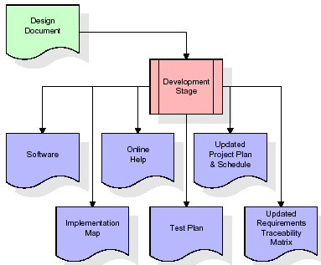

The RTM will be updated to show that each developed artifact is linked to a specific design element, and that each developed artifact has one or more corresponding test case items. At this point, the RTM is in its final configuration. The outputs of the development stage include a fully functional set of software that satisfies the requirements and design elements previously documented, an online help system that describes the operation of the software, an implementation map that identifies the primary code entry points for all major system functions, a test plan that describes the test cases to be used to validate the correctness and completeness of the software, an updated RTM, and an updated project plan.
Integration & Test Stage:
During the integration and test stage, the software artifacts, online help, and test data are migrated from the development environment to a separate test environment. At this point, all test cases are run to verify the correctness and completeness of the software. Successful execution of the test suite confirms a robust and complete migration capability. During this stage, reference data is finalized for production use and production users are identified and linked to their appropriate roles. The final reference data (or links to reference data source files) and production user list are compiled into the Production Initiation Plan.
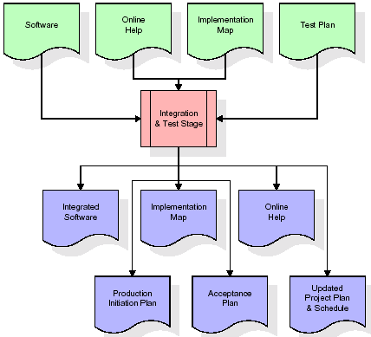
The outputs of the integration and test stage include an integrated set of software, an online help system, an implementation map, a production initiation plan that describes reference data and production users, an acceptance plan which contains the final suite of test cases, and an updated project plan.
- Installation & Acceptance Test:
During the installation and acceptance stage, the software artifacts, online help, and initial production data are loa ded onto the production server. At this point, all test cases are run to verify the correctness and completeness of the software. Successful execution of the test suite is a prerequisite to acceptance of the software by the customer.
After customer personnel have verified that the initial production data load is correct and the test suite has been executed with satisfactory results, the customer formally accepts the delivery of the software.
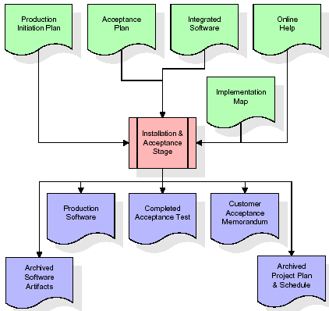
The primary outputs of the installation and acceptance stage include a production application, a completed acceptance test suite, and a memorandum of customer acceptance of the software. Finally, the PDR enters the last of the actual labor data into the project schedule and locks the project as a permanent project record. At this point the PDR "locks" the project by archiving all software items, the implementation map, the source code, and the documentation for future reference.

Maintenance:
Outer rectangle represents maintenance of a project, Maintenance team will start with requirement study, understanding of documentation later employees will be assigned work and they will undergo training on that particular assigned category. For this life cycle there is no end, it will be continued so on like an umbrella (no ending point to umbrella sticks).
3.4. Software Requirement Specification
3.4.1. Overall Description
A Software Requirements Specification (SRS) – a requirements specification for a software system is a complete description of the behavior of a system to be developed. It includes a set of use cases that describe all the interactions the users will have with the software. In addition to use cases, the SRS also contains non-functional requirements. Nonfunctional requirements are requirements which impose constraints on the design or implementation (such as performance engineering requirements, quality standards, or design constraints).
System requirements specification: A structured collection of information that embodies the requirements of a system. A business analyst, sometimes titled system analyst, is responsible for analyzing the business needs of their clients and stakeholders to help identify business problems and propose solutions. Within the systems development lifecycle domain, the BA typically performs a liaison function between the business side of an enterprise and the information technology department or external service providers. Projects are subject to three sorts of requirements:
- Business requirements describe in business terms what must be delivered or accomplished to provide value.
- Product requirements describe properties of a system or product (which could be one of several ways to accomplish a set of business requirements.)
- Process requirements describe activities performed by the developing organization. For instance, process requirements could specify .Preliminary investigation examine project feasibility, the likelihood the system will be useful to the organization. The main objective of the feasibility study is to test the Technical, Operational and Economical feasibility for adding new modules and debugging old running system. All system is feasible if they are unlimited resources and infinite time. There are aspects in the feasibility study portion of the preliminary investigation:
- ECONOMIC FEASIBILITY
A system can be developed technically and that will be used if installed must still be a good investment for the organization. In the economical feasibility, the development cost in creating the system is evaluated against the ultimate benefit derived from the new systems. Financial benefits must equal or exceed the costs. The system is economically feasible. It does not require any addition hardware or software. Since the interface for this system is developed using the existing resources and technologies available at NIC, There is nominal expenditure and economical feasibility for certain.
- Operational Feasibility
Proposed projects are beneficial only if they can be turned out into information system. That will meet the organization’s operating requirements. Operational feasibility aspects of the project are to be taken as an important part of the project implementation. This system is targeted to be in accordance with the above-mentioned issues. Beforehand, the management issues and user requirements have been taken into consideration. So there is no question of resistance from the users that can undermine the possible application benefits. The well-planned design would ensure the optimal utilization of the computer resources and would help in the improvement of performance status.
- TECHNICAL FEASIBILITY
Earlier no system existed to cater to the needs of ‘Secure Infrastructure Implementation System’. The current system developed is technically feasible. It is a web based user interface for audit workflow at NIC-CSD. Thus it provides an easy access to .the users. The database’s purpose is to create, establish and maintain a workflow among various entities in order to facilitate all concerned users in their various capacities or roles. Permission to the users would be granted based on the roles specified. Therefore, it provides the technical guarantee of accuracy, reliability and security.
3.4.2. External Interface Requirements
User Interface
The user interface of this system is a user friendly python Graphical User Interface.
Hardware Interfaces
The interaction between the user and the console is achieved through python capabilities.
Software Interfaces
The required software is python.
SYSTEM REQUIREMENT:
HARDWARE REQUIREMENTS:

Processor - Intel i3(min)
- Speed - 1.1 GHz
- RAM - 4GB(min)
- Hard Disk - 500 GB
- Key Board - Standard Windows Keyboard
- Mouse - Two or Three Button Mouse
- Monitor - SVGA
SOFTWARE REQUIREMENTS:
- Operating System - Windows10(min)
- Programming Language - Python

4. SYSTEM DESIGN
4. SYSTEM DESIGN
CLASS DIAGRAM:
The class diagram is the main building block of object oriented modeling. It is used both for general conceptual modeling of the systematic of the application, and for detailed modeling translating the models into programming code. Class diagrams can also be used for data modeling. The classes in a class diagram represent both the main objects, interactions in the application and the classes to be programmed. In the diagram, classes are represented with boxes which contain three parts:
- The upper part holds the name of the class
- The middle part contains the attributes of the class
- The bottom part gives the methods or operations the class can take or undertake
USECASE DIAGRAM:
A use case diagram at its simplest is a representation of a user's interaction with the system and depicting the specifications of a use case. A use case diagram can portray the different types of users of a system and the various ways that they interact with the system. This type of diagram is typically used in conjunction with the textual use case and will often be accompanied by other types of diagrams as well.
SEQUENCE DIAGRAM:
A sequence diagram is a kind of interaction diagram that shows how processes operate with one another and in what order. It is a construct of a Message Sequence Chart. A sequence diagram shows object interactions arranged in time sequence. It depicts the objects and classes involved in the scenario and the sequence of messages exchanged between the objects needed to carry out the functionality of the scenario. Sequence diagrams are typically associated with use case realizations in the Logical View of the system under development. Sequence diagrams are sometimes called event diagrams, event scenarios, and timing diagrams.
COLLABORATION DIAGRAM:
A collaboration diagram describes interactions among objects in terms of sequenced messages. Collaboration diagrams represent a combination of information taken from class, sequence, and use case diagrams describing both the static structure and dynamic behaviour of a system.

COMPONENT DIAGRAM:
In the Unified Modelling Language, a component diagram depicts how components are wired together to form larger components and or software systems. They are used to illustrate the structure of arbitrarily complex systems.
Components are wired together by using an assembly connector to connect the required interface of one component with the provided interface of another component. This illustrates the service consumer - service provider relationship between the two components.

DEPLOYMENT DIAGRAM:
A deployment diagram in the Unified Modeling Language models the physical deployment of artifacts on nodes. To describe a web site, for example, a deployment diagram would show what hardware components ("nodes") exist (e.g., a web server, an application server, and a database server), what software components ("artifacts") run on each node (e.g., web application, database), and how the different pieces are connected (e.g. JDBC, REST, RMI).
The nodes appear as boxes, and the artifacts allocated to each node appear as rectangles within the boxes. Nodes may have sub nodes, which appear as nested boxes. A single node in a deployment diagram may conceptually represent multiple physical nodes, such as a cluster of database servers.
ACTIVITY DIAGRAM:
Activity diagram is another important diagram in UML to describe dynamic aspects of the system. It is basically a flow chart to represent the flow form one activity to another activity. The activity can be described as an operation of the system. So the control flow is drawn from one operation to another. This flow can be sequential, branched or concurrent.
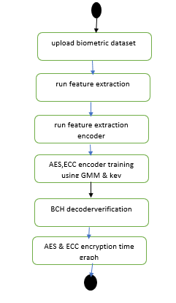

Data flow :
Data flow diagrams illustrate how data is processed by a system in terms of inputs and outputs. Data flow diagrams can be used to provide a clear representation of any business function. The technique starts with an overall picture of the business and continues by analyzing each of the functional areas of interest. This analysis can be carried out in precisely the level of detail required. The technique exploits a method called top-down expansion to conduct the analysis in a targeted way.
As the name suggests, Data Flow Diagram (DFD) is an illustration that explicates the passage of information in a process. A DFD can be easily drawn using simple symbols. Additionally, complicated processes can be easily automated by creating DFDs using easy-to-use, free downloadable diagramming tools. A DFD is a model for constructing and analyzing information processes. DFD illustrates the flow of information in a process depending upon the inputs and outputs. A DFD can also be referred to as a Process Model. A DFD demonstrates business or technical process with the support of the outside data saved, plus the data flowing from the process to another and the end results.

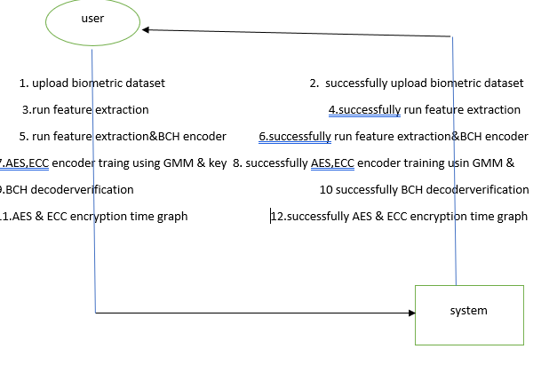

CLASS DIAGRAM:
The class diagram is the main building block of object oriented modeling. It is used both for general conceptual modeling of the systematic of the application, and for detailed modeling translating the models into programming code. Class diagrams can also be used for data modeling. The classes in a class diagram represent both the main objects, interactions in the application and the classes to be programmed. In the diagram, classes are represented with boxes which contain three parts:
- The upper part holds the name of the class
- The middle part contains the attributes of the class
- The bottom part gives the methods or operations the class can take or undertake

USECASE DIAGRAM:
A use case diagram at its simplest is a representation of a user's interaction with the system and depicting the specifications of a use case. A use case diagram can portray the different types of users of a system and the various ways that they interact with the system. This type of diagram is typically used in conjunction with the textual use case and will often be accompanied by other types of diagrams as we
SEQUENCE DIAGRAM
A sequence diagram is a kind of interaction diagram that shows how processes operate with one another and in what order. It is a construct of a Message Sequence Chart. A sequence diagram shows object interactions arranged in time sequence. It depicts the objects and classes involved in the scenario and the sequence of messages exchanged between the objects needed to carry out the functionality of the scenario. Sequence diagrams are typically associated with use case realizations in the Logical View of the system under development. Sequence diagrams are sometimes called event diagrams, event scenarios, and timing diagrams.
COLLABORATION DIAGRAM:
A collaboration diagram describes interactions among objects in terms of sequenced messages. Collaboration diagrams represent a combination of information taken from class, sequence, and use case diagrams describing both the static structure and dynamic behaviour of a system.

user
upload
datset
random
forest
feature
extraction
Upload Test Image & Classify Bone
test train
generator
1: upload datest
2: successfully upload dataset
3: feature extraction
4: successfully run feature extraction
5: test train generator
6: successfully run test train generator
7: random forest
8: successfully run random forest
9: Upload Test Image
& Classify Bone
10: Upload Test Image & Classify Bone

COMPONENT DIAGRAM:
In the Unified Modelling Language, a component diagram depicts how components are wired together to form larger components and or software systems. They are used to illustrate the structure of arbitrarily complex systems.
Components are wired together by using an assembly connector to connect the required interface of one component with the provided interface of another component. This illustrates the service consumer - service provider relationship between the two components.

DEPLOYMENT DIAGRAM:
A deployment diagram in the Unified Modeling Language models the physical deployment of artifacts on nodes. To describe a web site, for example, a deployment diagram would show what hardware components ("nodes") exist (e.g., a web server, an application server, and a database server), what software components ("artifacts") run on each node (e.g., web application, database), and how the different pieces are connected (e.g. JDBC, REST, RMI).
The nodes appear as boxes, and the artifacts allocated to each node appear as rectangles within the boxes. Nodes may have sub nodes, which appear as nested boxes. A single node in a deployment diagram may conceptually represent multiple physical nodes, such as a cluster of database servers.
ACTIVITY DIAGRAM:
Activity diagram is another important diagram in UML to describe dynamic aspects of the system. It is basically a flow chart to represent the flow form one activity to another activity. The activity can be described as an operation of the system. So the control flow is drawn from one operation to another. This flow can be sequential, branched or concurrent
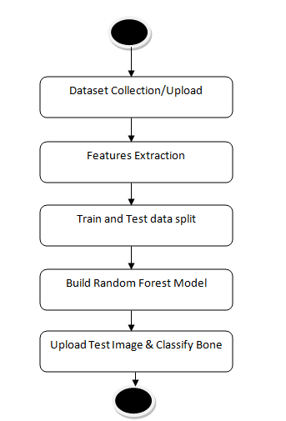

Data flow :
Data flow diagrams illustrate how data is processed by a system in terms of inputs and outputs. Data flow diagrams can be used to provide a clear representation of any business function. The technique starts with an overall picture of the business and continues by analyzing each of the functional areas of interest. This analysis can be carried out in precisely the level of detail required. The technique exploits a method called top-down expansion to conduct the analysis in a targeted way.
As the name suggests, Data Flow Diagram (DFD) is an illustration that explicates the passage of information in a process. A DFD can be easily drawn using simple symbols. Additionally, complicated processes can be easily automated by creating DFDs using easy-to-use, free downloadable diagramming tools. A DFD is a model for constructing and analyzing information processes. DFD illustrates the flow of information in a process depending upon the inputs and outputs. A DFD can also be referred to as a Process Model. A DFD demonstrates business or technical process with the support of the outside data saved, plus the data flowing from the process to another and the end results.

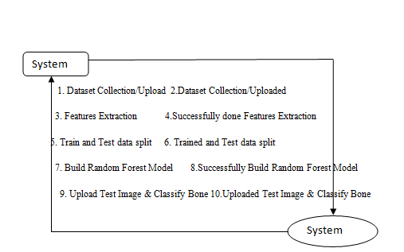

5. IMPLEMETATION
5.1 Python
Python is a general-purpose language. It has wide range of applications from Web development (like: Django and Bottle), scientific and mathematical computing (Orange, SymPy, NumPy) to desktop graphical user Interfaces (Pygame, Panda3D). The syntax of the language is clean and length of the code is relatively short. It's fun to work in Python because it allows you to think about the problem rather than focusing on the syntax.
History of Python:
Python is a fairly old language created by Guido Van Rossum. The design began in the late 1980s and was first released in February 1991.
Why Python was created?
In late 1980s, Guido Van Rossum was working on the Amoeba distributed operating system group. He wanted to use an interpreted language like ABC (ABC has simple easy-to-understand syntax) that could access the Amoeba system calls. So, he decided to create a language that was extensible. This led to design of a new language which was later named Python.
Why the name Python?
No. It wasn't named after a dangerous snake. Rossum was fan of a comedy series from late seventies. The name "Python" was adopted from the same series "Monty Python's Flying Circus".
Features of Python:
A simple language which is easier to learn
Python has a very simple and elegant syntax. It's much easier to read and write Python programs compared to other languages like: C++, Java, C#. Python makes programming fun and allows you to focus on the solution rather than syntax.
If you are a newbie, it's a great choice to start your journey with Python.
Free and open-source
You can freely use and distribute Python, even for commercial use. Not only can you use and distribute software’s written in it, you can even make changes to the Python's source code.
Python has a large community constantly improving it in each iteration.
Portability
You can move Python programs from one platform to another, and run it without any changes.
It runs seamlessly on almost all platforms including Windows, Mac OS X and Linux.
Extensible and Embeddable
Suppose an application requires high performance. You can easily combine pieces of C/C++ or other languages with Python code.
This will give your application high performance as well as scripting capabilities which other languages may not provide out of the box.
A high-level, interpreted language
Unlike C/C++, you don't have to worry about daunting tasks like memory management, garbage collection and so on.
Likewise, when you run Python code, it automatically converts your code to the language your computer understands. You don't need to worry about any lower-level operations.
Large standard libraries to solve common tasks
Python has a number of standard libraries which makes life of a programmer much easier since you don't have to write all the code yourself. For example: Need to connect MySQL database on a Web server? You can use MySQLdb library using import MySQLdb .
Standard libraries in Python are well tested and used by hundreds of people. So you can be sure that it won't break your application.
Object-oriented
Everything in Python is an object. Object oriented programming (OOP) helps you solve a complex problem intuitively.
With OOP, you are able to divide these complex problems into smaller sets by creating objects.
Applications of Python:
1. Simple Elegant Syntax
Programming in Python is fun. It's easier to understand and write Python code. Why? The syntax feels natural. Take this source code for an example:
a = 2
b = 3
sum = a + b
print(sum)
2. Not overly strict
You don't need to define the type of a variable in Python. Also, it's not necessary to add semicolon at the end of the statement.
Python enforces you to follow good practices (like proper indentation). These small things can make learning much easier for beginners.
3. Expressiveness of the language
Python allows you to write programs having greater functionality with fewer lines of code. Here's a link to the source code of Tic-tac-toe game with a graphical interface and a smart computer opponent in less than 500 lines of code. This is just an example. You will be amazed how much you can do with Python once you learn the basics.
4. Great Community and Support
Python has a large supporting community. There are numerous active forums online which can be handy if you are stuck.

5.2 Sample Code:
from tkinter import messagebox
from tkinter import *
from tkinter import simpledialog
import tkinter
from tkinter import filedialog
from tkinter.filedialog import askopenfilename
import os
import numpy as np
import cv2
import matplotlib.pyplot as plt
from sklearn.decomposition import PCA
from sklearn.mixture import GaussianMixture
from sklearn.metrics import accuracy_score
import pickle
from ecies.utils import generate_eth_key, generate_key
from ecies import encrypt, decrypt #importing classes for ECC encryption
import pyaes, pbkdf2, binascii, os, secrets #importing classes for AES as PYAES
import time

main = tkinter.Tk()
main.title("Secure crypto-biometric system for cloud computing")
main.geometry("1300x1200")

global filename, pathlabel
global X, Y, encoder, pca, gmm
global labels
global ecc_publicKey,ecc_privateKey #defining public and private keys variables for ECC
global aes_time, ecc_time

def ECCEncrypt(obj): #ECC encryption function
enc = encrypt(ecc_publicKey, obj)
return enc

def ECCDecrypt(obj): #ECC decryption function
dec = decrypt(ecc_privateKey, obj)
return dec

def generateKey(): #function to generate ECC keys
global ecc_publicKey,ecc_privateKey
eth_k = generate_eth_key()
ecc_private_key = eth_k.to_hex()
ecc_public_key = eth_k.public_key.to_hex()
return ecc_private_key, ecc_public_key

def getAesKey(): #generating key with PBKDF2 for AES
password = "s3cr3t*c0d3"
passwordSalt = '76895'
key = pbkdf2.PBKDF2(password, passwordSalt).read(32)
return key

def Aesencrypt(plaintext): #AES data encryption
aes = pyaes.AESModeOfOperationCTR(getAesKey(), pyaes.Counter(31129547035000047302952433967654195398124239844566322884172163637846056248223))
ciphertext = aes.encrypt(plaintext)
return ciphertext

def Aesdecrypt(enc): #AES data decryption
aes = pyaes.AESModeOfOperationCTR(getAesKey(), pyaes.Counter(31129547035000047302952433967654195398124239844566322884172163637846056248223))
decrypted = aes.decrypt(enc)
return decrypted

def readLabels(path):
global labels
for root, dirs, directory in os.walk(path):
for j in range(len(directory)):
name = os.path.basename(root)
if name not in labels:
labels.append(name)

def getID(name):
label = 0
for i in range(len(labels)):
if name == labels[i]:
label = i
break
return label

def uploadDatabase():
global filename, labels
labels = []
filename = filedialog.askdirectory(initialdir=".")
pathlabel.config(text=filename)
text.delete('1.0', END)
text.insert(END,filename+" loaded\n\n")
readLabels(filename)
text.insert(END,"Total persons biometric templates found in Database: "+str(len(labels))+"\n\n")
text.insert(END,"Person Details\n\n")
text.insert(END, str(labels))

def featuresExtraction():
global filename
text.delete('1.0', END)
global X, Y
if os.path.exists("model/X.npy"):
X = np.load("model/X.npy")
Y = np.load("model/Y.npy")
else:
X = []
Y = []
for root, dirs, directory in os.walk(filename):
for j in range(len(directory)):
name = os.path.basename(root)
if 'Thumbs.db' not in directory[j]:
img = cv2.imread(root+"/"+directory[j],0)
img = cv2.resize(img, (28,28))
label = getID(name)
X.append(img.ravel())
Y.append(label)
print(str(label)+" "+name)
X = np.asarray(X)
Y = np.asarray(Y)
X = X.astype('float32')
X = X/255
np.save("model/X", X)
np.save("model/Y", Y)
text.insert(END,"Extracted Features from templates\n\n")
text.insert(END,str(X))

def featuresSelection():
text.delete('1.0', END)
global X, Y, pca, encoder
text.insert(END,"Total features available in templates before applying PCA features selection: "+str(X.shape[1])+"\n\n")
pca = PCA(n_components=60)
X = pca.fit_transform(X)
text.insert(END,"Total features available in templates after applying PCA features selection: "+str(X.shape[1])+"\n\n")
text.insert(END,"Encoder features after encrypting with KEY\n\n")
encoder = []
for i in range(len(X)):
temp = []
for j in range(len(X[i])):
temp.append(X[i,j]**2)
encoder.append(temp)
encoder = np.asarray(encoder)
text.insert(END,str(encoder))

def runGMMEncoding():
text.delete('1.0', END)
global ecc_publicKey,ecc_privateKey
global aes_time, ecc_time
global encoder, Y, gmm
if os.path.exists('model/gmm.txt'):
with open('model/gmm.txt', 'rb') as file:
gmm = pickle.load(file)
file.close()
else:
gmm = GaussianMixture(n_components=10, max_iter = 1000)
gmm.fit(encoder, Y)
#gmm is the object which is used for verification and it contains all templates details so GMM has to get encrypted
start = time.time()
ecc_privateKey, ecc_publicKey = generateKey()#getting ECC keys
gmm = ECCEncrypt(pickle.dumps(gmm))#now encrypting GMM using ECC
gmm = pickle.loads(ECCDecrypt(gmm))#now decrypting GMM using ECC
end = time.time()
ecc_time = end - start #calculating ECC encryption and decryption time

#now encrypting with AES
start = time.time() #getting AES start time
gmm = Aesencrypt(pickle.dumps(gmm)) #doing AES encryption on GMM
encrypted_data = gmm[0:400]
end = time.time()
aes_time = end - start #calculating AES encryption and decryption time
gmm = pickle.loads(Aesdecrypt(gmm)) #doing AES decryption on GMM
ecc_time = ecc_time * 4
text.insert(END,"Encoder training & AES & ECC Encryption process completed on GMM\n\n")
text.insert(END,"Time taken by AES : "+str(aes_time)+"\n\n")
text.insert(END,"Time taken by ECC : "+str(ecc_time)+"\n\n")
text.insert(END,"Encrypted Data\n\n")
text.insert(END,str(encrypted_data))

def verification():
text.delete('1.0', END)
global pca, gmm
filename = filedialog.askopenfilename(initialdir="testImages")
img = cv2.imread(filename,0)
img = cv2.resize(img, (28,28))
test = []
test.append(img.ravel())
test = np.asarray(test)
test = test.astype('float32')
test = test/255
test = pca.transform(test)
decoder = []
for i in range(len(test)):
temp = []
for j in range(len(test[i])):
temp.append(test[i,j]**2)
decoder.append(temp)
decoder = np.asarray(decoder)
predict = gmm.predict(decoder)[0]
img = cv2.imread(filename)
img = cv2.resize(img, (600,400))
cv2.putText(img, 'Biometric template belongs to person : '+str(predict), (10, 25), cv2.FONT_HERSHEY_SIMPLEX,0.7, (255, 0, 0), 2)
cv2.imshow('Biometric template belongs to person : '+str(predict), img)
cv2.waitKey(0)

def graph():
global aes_time, ecc_time
height = [aes_time, ecc_time]
bars = ('AES Execution Time','ECC Execution Time')
y_pos = np.arange(len(bars))
plt.bar(y_pos, height)
plt.xticks(y_pos, bars)
plt.title("AES & ECC Execution Time Graph")
plt.show()

def GUI():
global text, main, pathlabel
font = ('times', 16, 'bold')
title = Label(main, text='Secure crypto-biometric system for cloud computing')
title.config(bg='brown', fg='white')
title.config(font=font)
title.config(height=3, width=120)
title.place(x=0,y=5)

font1 = ('times', 13, 'bold')
uploadButton = Button(main, text="Upload Biometric Database", command=uploadDatabase)
uploadButton.place(x=50,y=100)
uploadButton.config(font=font1)

pathlabel = Label(main)
pathlabel.config(bg='brown', fg='white')
pathlabel.config(font=font1)
pathlabel.place(x=460,y=100)

extractionButton = Button(main, text="Run Features Extraction", command=featuresExtraction)
extractionButton.place(x=50,y=150)
extractionButton.config(font=font1)

selectionButton = Button(main, text="Run Features Selection & BCH Encoder", command=featuresSelection)
selectionButton.place(x=330,y=150)
selectionButton.config(font=font1)

encodingButton = Button(main, text="AES, ECC Encoder Training using GMM & Key", command=runGMMEncoding)
encodingButton.place(x=720,y=150)
encodingButton.config(font=font1)

verificationButton = Button(main, text="BCH Decoder Verification", command=verification)
verificationButton.place(x=50,y=200)
verificationButton.config(font=font1)

graphButton = Button(main, text="AES & ECC Encryption Time Graph", command=graph)
graphButton.place(x=330,y=200)
graphButton.config(font=font1)

font1 = ('times', 12, 'bold')
text=Text(main,height=20,width=150)
scroll=Scrollbar(text)
text.configure(yscrollcommand=scroll.set)
text.place(x=10,y=250)
text.config(font=font1)

main.config(bg='brown')
main.mainloop()

if __name__ == "__main__":
GUI()

6. TESTING:
Implementation and Testing:
Implementation is one of the most important tasks in project is the phase in which one has to be cautions because all the efforts undertaken during the project will be very interactive. Implementation is the most crucial stage in achieving successful system and giving the users confidence that the new system is workable and effective. Each program is tested individually at the time of development using the sample data and has verified that these programs link together in the way specified in the program specification. The computer system and its environment are tested to the satisfaction of the user.

Implementation

The implementation phase is less creative than system design. It is primarily concerned with user training, and file conversion. The system may be requiring extensive user training. The initial parameters of the system should be modifies as a result of a programming. A simple operating procedure is provided so that the user can understand the different functions clearly and quickly. The different reports can be obtained either on the inkjet or dot matrix printer, which is available at the disposal of the user. The proposed system is very easy to implement. In general implementation is used to mean the process of converting a new or revised system design into an operational one.

Testing
Testing is the process where the test data is prepared and is used for testing the modules individually and later the validation given for the fields. Then the system testing takes place which makes sure that all components of the system property functions as a unit. The test data should be chosen such that it passed through all possible condition. Actually testing is the state of implementation which aimed at ensuring that the system works accurately and efficiently before the actual operation commence. The following is the description of the testing strategies, which were carried out during the testing period.

System Testing
Testing has become an integral part of any system or project especially in the field of information technology. The importance of testing is a method of justifying, if one is ready to move further, be it to be check if one is capable to with stand the rigors of a particular situation cannot be underplayed and that is why testing before development is so critical. When the software is developed before it is given to user to use the software must be tested whether it is solving the purpose for which it is developed. This testing involves various types through which one can ensure the software is reliable. The program was tested logically and pattern of execution of the program for a set of data are repeated. Thus the code was exhaustively checked for all possible correct data and the outcomes were also checked.
Module Testing
To locate errors, each module is tested individually. This enables us to detect error and correct it without affecting any other modules. Whenever the program is not satisfying the required function, it must be corrected to get the required result. Thus all the modules are individually tested from bottom up starting with the smallest and lowest modules and proceeding to the next level. Each module in the system is tested separately. For example the job classification module is tested separately. This module is tested with different job and its approximate execution time and the result of the test is compared with the results that are prepared manually. The comparison shows that the results proposed system works efficiently than the existing system. Each module in the system is tested separately. In this system the resource classification and job scheduling modules are tested separately and their corresponding results are obtained which reduces the process waiting time.
Integration Testing
After the module testing, the integration testing is applied. When linking the modules there may be chance for errors to occur, these errors are corrected by using this testing. In this system all modules are connected and tested. The testing results are very correct. Thus the mapping of jobs with resources is done correctly by the system.

Acceptance Testing
When that user fined no major problems with its accuracy, the system passers through a final acceptance test. This test confirms that the system needs the original goals, objectives and requirements established during analysis without actual execution which elimination wastage of time and money acceptance tests on the shoulders of users and management, it is finally acceptable and ready for the operation.
Test Case Id | Test Case Name | Test Case Desc. | Test Steps |  |  |  | Test Case Status | Test Priority
 |  |  | Step | Expected |  | Actual
01 | Upload Biometric Database | Verify  Upload Biometric Database or not | If User may not upload | we cannot do any further operations | we can do further operations |  | High | High
02 | Run Features Extraction | Verify Run Features Extraction or not | If Run Features Extraction may not be Done | we cannot do any further operations | we can do further operations |  | High | High
03 | Run Features Selection & BCH Encoder | Verify Run Features Selection & BCH Encoder or not | If Run Features Selection & BCH Encoder may not be done | we cannot do any further operations | we can do further operations |  | High | High
04 | Encoder Training using GMM & Key | Verify Encoder Training using GMM & Key or not | If Encoder Training using GMM & Key may not Run | We cannot run  operation | We can Run the Operation |  | High | High
05 | BCH Decoder Verification | Verify BCH Decoder Verification or not | If BCH Decoder May not verified | we cannot do any further operations | we can do further operations |  | High | High

FUNCTIONAL REQUIREMENTS:
1.SOFTWARE REQIREMENTS:
System Atributes:
filename, pathlabel
X, Y, encoder, pca, gmm
labels
ecc_publicKey,ecc_privateKey #defining public and private keys

Data base Requirements:
No need
2.USECASE:
- Use cases - Use cases describe the interaction between the system and external users that leads to achieving particular goals.
- Each use case includes main elements:
- Upload Biometric Database
- Run Features Extraction
- Run Features Selection & BCH Encoder
- Encoder Training using GMM & Key
- BCH Decoder Verification

3.User Stories:
In propose paper author is using biometric database as Universal Background Model (UBM) whose features will be extracted using HMM (hidden markov model) algorithm and this algorithm will use Baum-Welch and LBG clustering technique to extract features from biometric template. Extracted features will get through PCA algorithm for features selection and then selected features will be encoded using Private Key. Encoded features will get train with GMM algorithm and above features encoding process is called as Fuzzy Commitment Template Protection
4.Work down Structure:
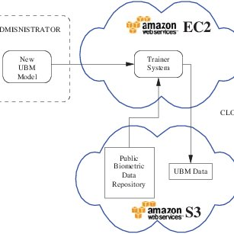

5.Prototype:
- python 3.7.0 or 3.7.4
- opencv-python==4.5.1.48
- keras==2.3.1
- tensorflow==1.14.0
- protobuf==3.16.0
- h5py==2.10.0
- sklearn-extensions==0.0.2
- scikit-learn==0.22.2.post1
- Numpy
- Pandas

6.Models and Diagrams:
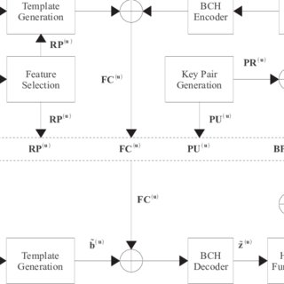
NON-FUNCTIONAL REQUIREMENT:
- Usability: Usability is a quality attribute that assesses how easy user interfaces are to use. The word "usability" also refers to methods for improving ease-of-use during the design process.(how it was handle entire project easy)
- Security:the quality or state of being secure: such as. a : freedom from danger : safety. b : freedom from fear or anxiety. c : freedom from the prospect of being laid off job security.(
- Readability: Readability is the ease with which a reader can understand a written text.
- Performance: the execution of an action. : something accomplished : deed, feat. : the fulfillment of a claim, promise, or request : implementation. 3. : the action of representing a character in a play.
- Availability: the quality or state of being available trying to improve the availability of affordable housing. 2 : an available person or thing.
- Scalability:Scalability is the measure of a system's ability to increase or decrease in performance and cost in response to changes in application and system processing demands.

7. SCREENSHOTS:
Secure crypto-biometric system for cloud computing
Now-a-days all organizations or techie peoples are using cloud services to store and manage their business data as this cloud services provide heavy computing resources in cheaper cost but this advantage leads to an issue called data security as data store at cloud is away from user’s hand and can be misuse by cloud service provider or hacker.
In propose paper author is providing security to user’s data by employing HMM model. Many organizations will use employee’s biometric data for verification but storing such biometric data at cloud can be dangerous as it may steal or hack by hackers to gain access to company servers.
To overcome from this problem author is employing Crypt-Biometric which will convert user biometric data into encrypted format and only genuine verification system can only verify such data so if hacker get crypto-biometric data then he will not aware of decoder key so he cannot verify himself.
In propose paper author is using biometric database as Universal Background Model (UBM) whose features will be extracted using HMM (hidden markov model) algorithm and this algorithm will use Baum-Welch and LBG clustering technique to extract features from biometric template. Extracted features will get through PCA algorithm for features selection and then selected features will be encoded using Private Key. Encoded features will get train with GMM algorithm and above features encoding process is called as Fuzzy Commitment Template Protection.
Above procedure used for biometric template enrolment and then we apply same process for verification also.
To implement this project we have used biometric database of 10 persons and below screen showing those images
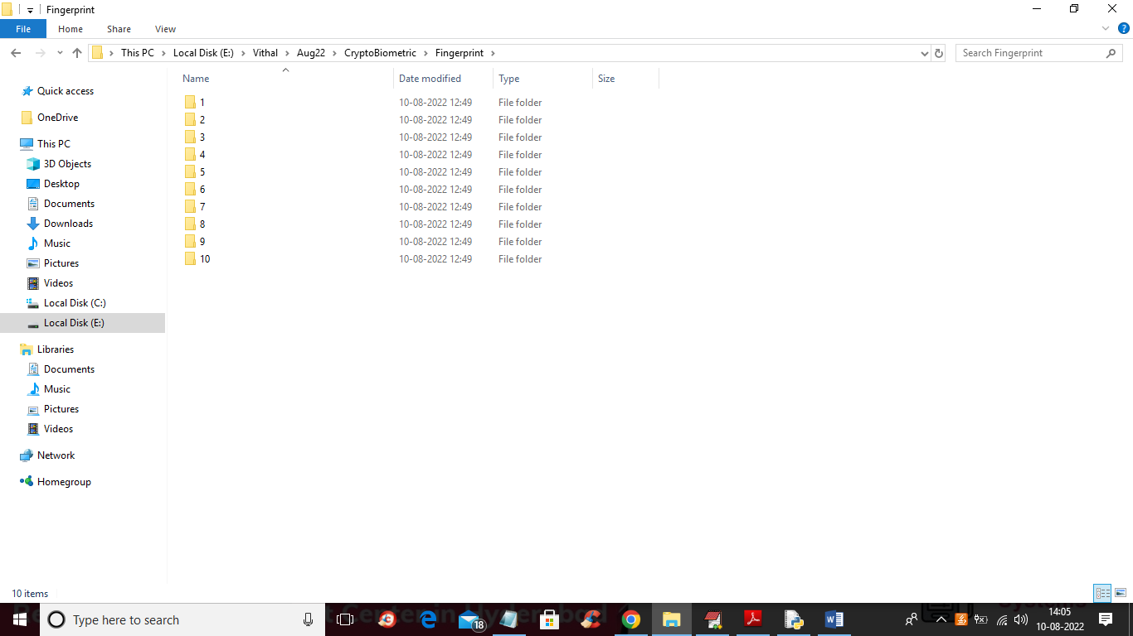
In above screen we have 10 folders for 10 person biometric details and below screen showing biometric images from above folders
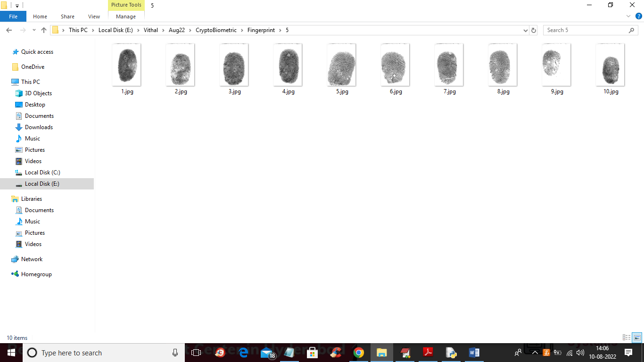
So by using above biometric database we are implementing crypto biometric concept.
In below screen we are showing code for Features extraction, features selection and then encoding with key and then training with GMM
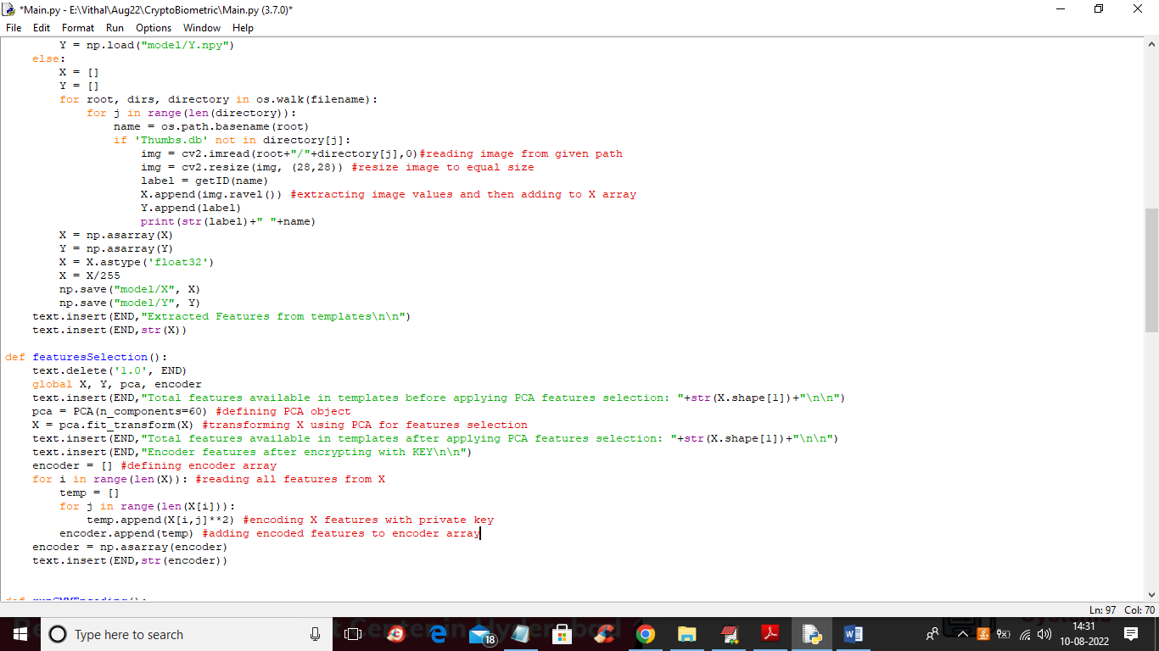
In above screen read red colour comments to know about features extraction, selection and encoding and in below screen we can see training with GMM
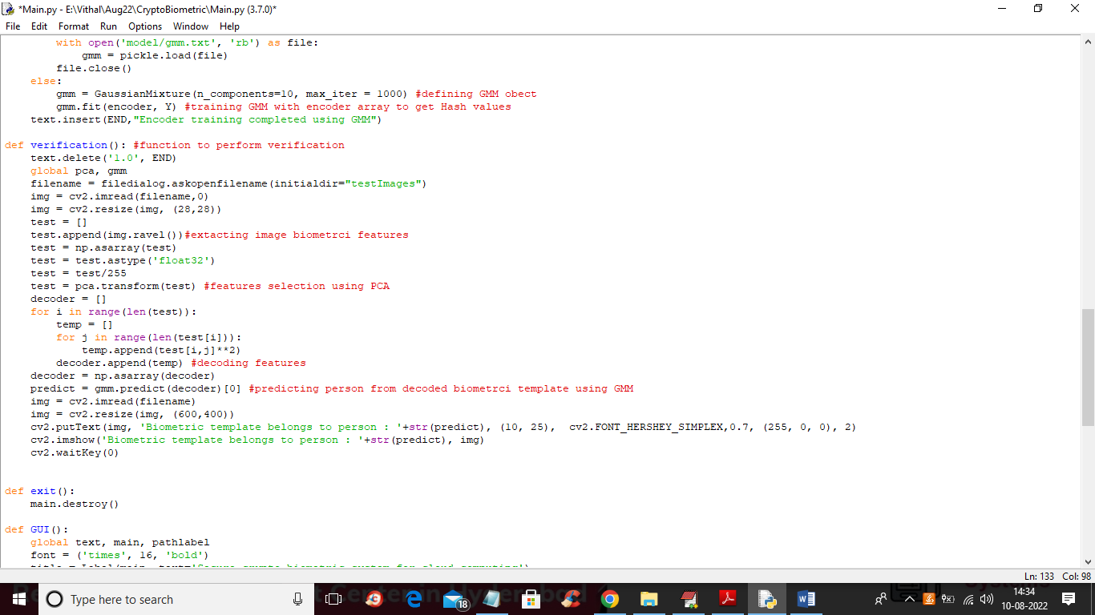
SCREEN SHOTS
To run project double click on ‘run.bat’ file to get below screen
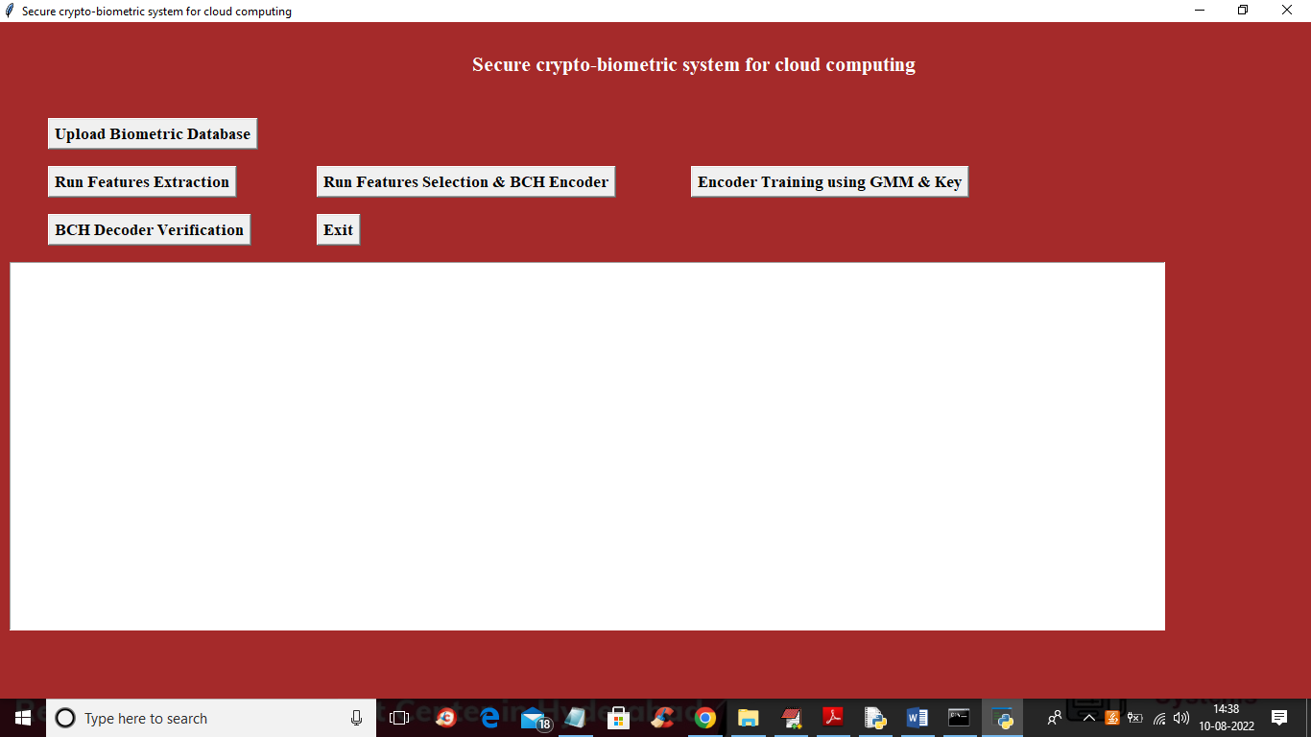
In above screen click on ‘Upload Biometric Database’ button to upload database and get below screen
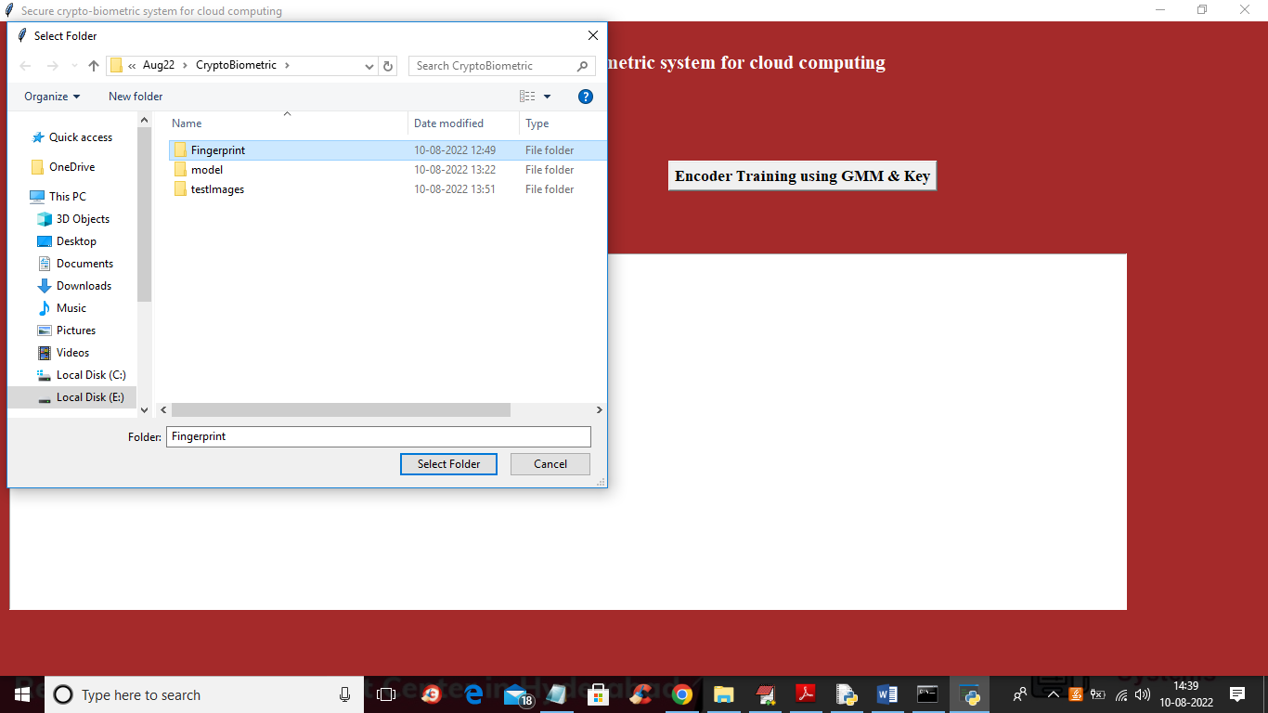
In above screen selecting and uploading finger print database and then click on ‘Select Folder’ button to load database and get below output
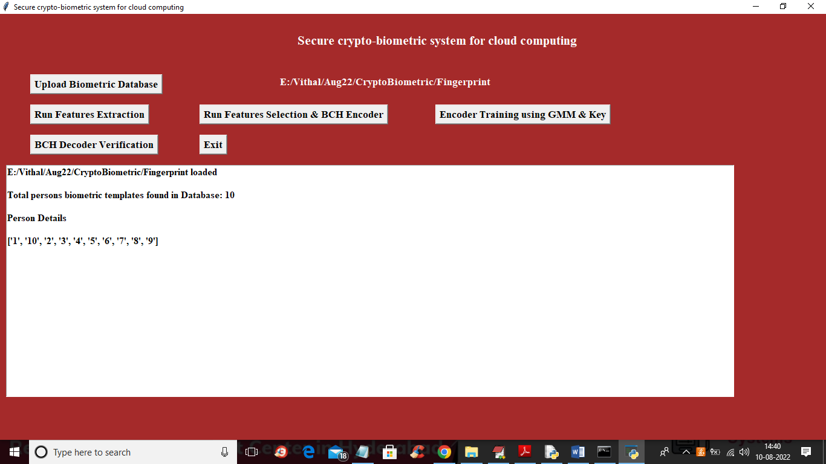
In above screen database loaded and it contains details of 10 persons and now click on ‘Run Features Extraction’ button to extract features from database and get below output
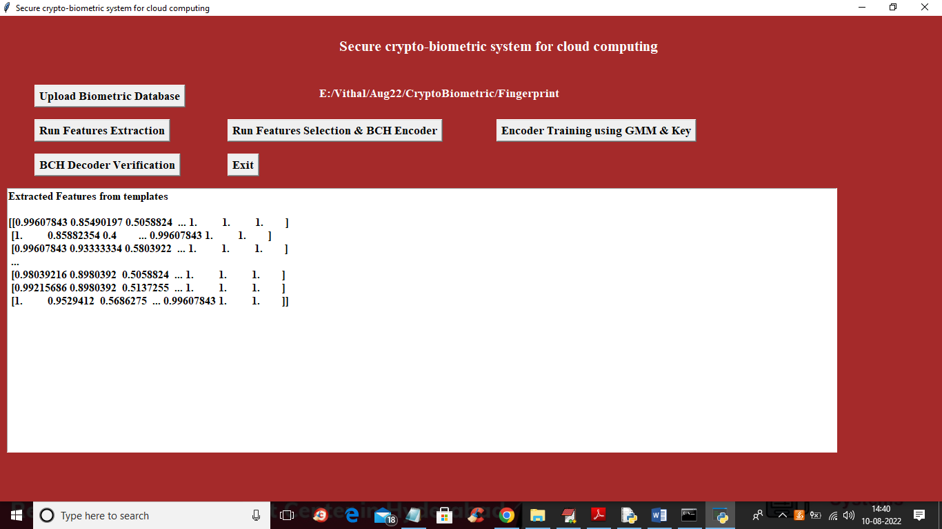
In above screen showing some extracted features from database and now click on ‘Run Features Selection & BCH Encoder’ button to select features and then apply encoding
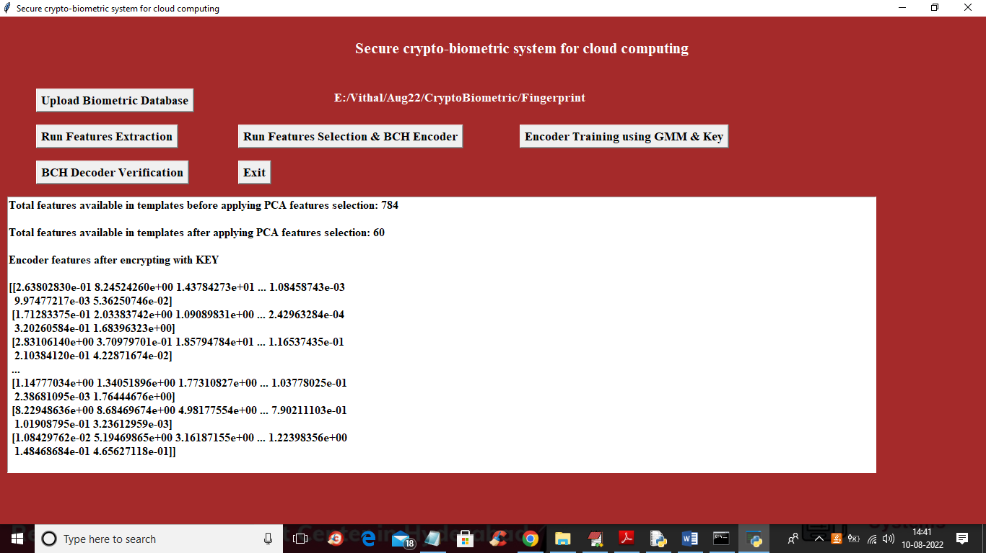
In above screen in first line we can see database contains 784 features in each template image and after applying PCA, selected features are 60 and then displaying encoder values after encryption with Key and this encoded features will get store in cloud instead of storing plain template so from above encoded values attacker wont gain access to server. Now click on ‘Encoder Training using GMM Key’ button to train GMM and get below output
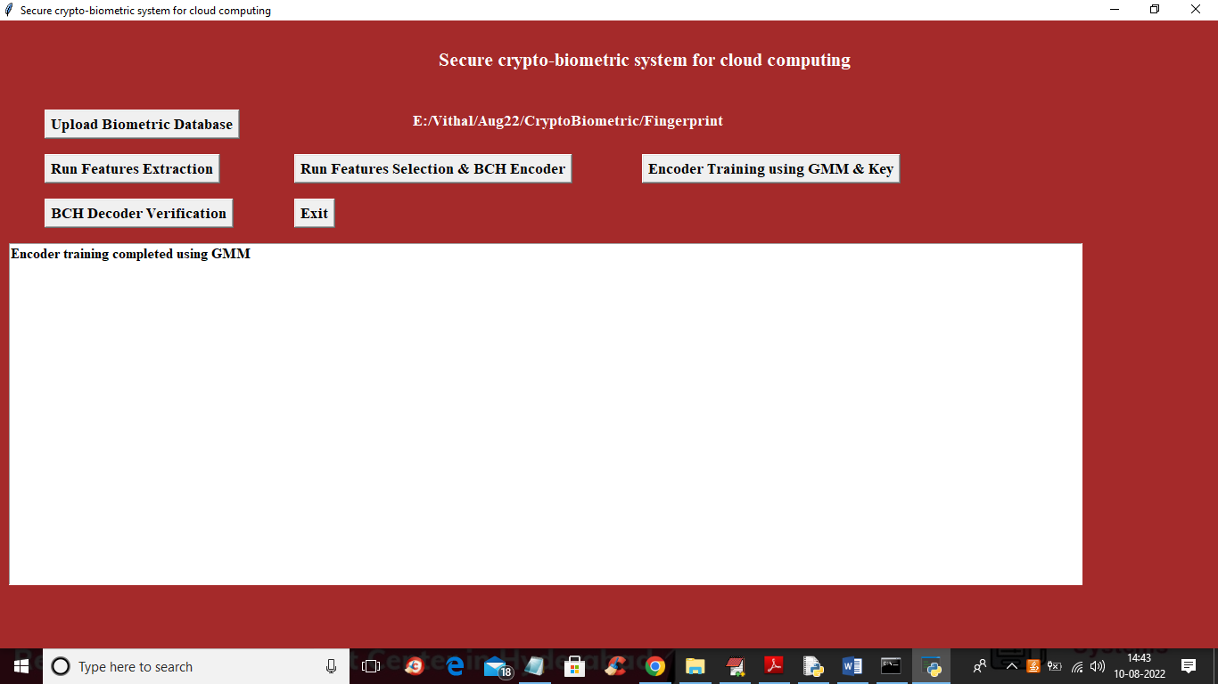
In above screen GMM training completed and now click on ‘BCH Decoder Verification’ button to upload TEST template and get below output
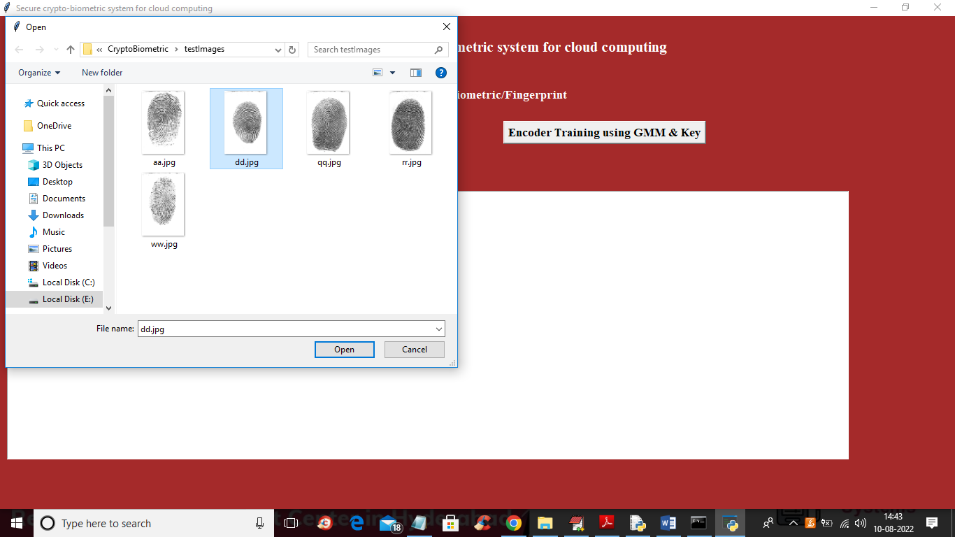
In above screen selecting and uploading ‘dd.jpg’ template and then click on ‘Open’ button to get below output
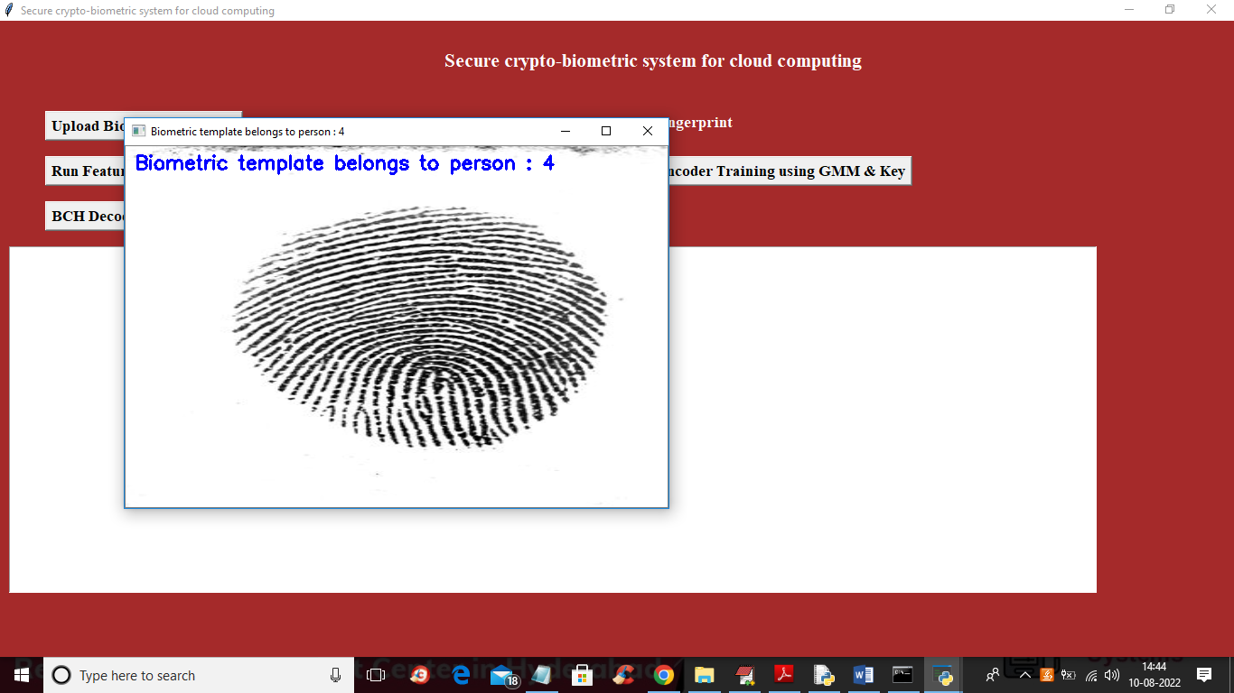
In above screen we can see uploaded template belongs to person 4 and similarly you can upload and verify other templates
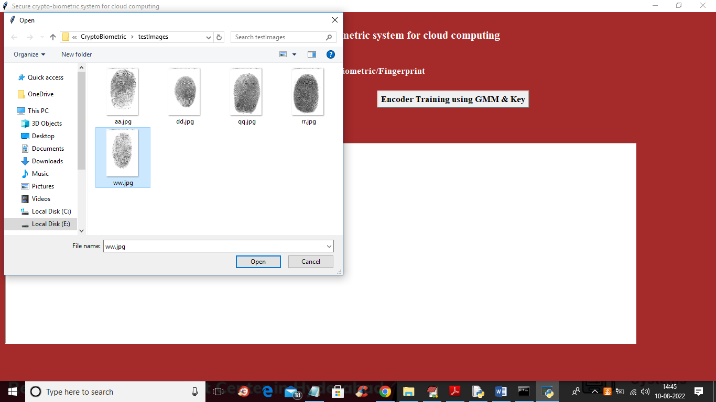
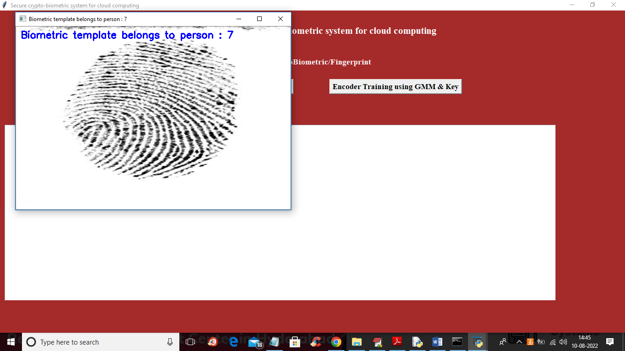
8. CONCLUSION:
We have proposed a feasible secure cryptographic system that is oriented to critical data in cloud environments. Biometric identification provides accurate, secure access to the information. A major difference between our model and other biometric schemas is that ours ensures that the cloud knows neither user biometric data nor the result of the biometric private matching identification. The lack of a direct matching process in our model enforces its security and makes it better conditioned for law compliance. We have proposed a method that allows a verifier to check the authenticity of the user, in a way that prevents the verifier from learning any information about the biometrics of the user. This schema is suitable for third-party cloud applications to provide security. A training system has been proposed to increase the models of the schema, improving security. This training system uses cloud resources to perform computationally intensive tasks efficiently. Authentication relies on a classic public and private key mechanism. This allows the system to take advantage of all the infrastructures based on certification authorities and the solutions based on that type of cryptography. There are a few aspects in our cryptobiometric system that can be improved. An important limitation is the required time to process biometric data in a client application. A complex combination of models may lead to excessive time to process user biometric information (a couple of seconds in the case of a 16-UBM system as previously described), affecting response time and the interactivity of the applications that rely on our schema. A thorough investigation to improve process time should be carried out. In this line, cloud computing resources could be very useful. Accordingly, the study of a secure way to process biometric data keeping it safe and inaccessible to third parties, including the cloud provider itself, is a future line of research. Finally, a complete Software as a Service solution can be developed to provide the functionality of our approach as a service.
9. REFERENCES:
[1] Balachandra Reddy Kandukuri, Ramakrishna Paturi V., Atanu Rakshit, Cloud Security Issues IEEE International Conference on Services Computing 2009, IEEE SCC 2009: 517-520, Bangalore, India, Sep 2009.
[2] R. Chow, P. Golle, M. Jakobsson, E. Shi, J. Staddon, R. Masuoka, and J. Molina, Controlling data in the cloud: outsourcing computation without outsourcing control. In Proceedings of the 2009 ACM Workshop on Cloud Computing Security (CCSW ’09): 85-90, ACM, New York, Nov 2009.
[3] S. Yu, C. Wang, K. Ren, and W. Lou, Achieving Secure, Scalable, and Fine-Grained Data Access Control in Cloud Computing, Proceedings of the 29th conference on Information communications, IEEE INFOCOM 2010: 534-542, San Diego, CA, USA, Mar 2010.
[4] C. Wang, Q. Wang, K. Ren, and W. Lou, Ensuring data storage security in Cloud Computing. 17th International Workshop on Quality of Service, IWQoS 2009: 1-9, Charleston, SC, USA, Jul 2009.
[5] S. Creese, P. Hopkins, S. Pearson, and Y. Shen, Data ProtectionAware Design for Cloud Services. Proceedings of the 1st International Conference on Cloud Computing, CloudCom ’09, LNCS 5931/2009: 119- 130, Beijing, China, Dec 2009.
[6] Q. Wang, C. Wang, J. Li, K. Ren, W. Lou, Enabling Public Verifiability and Data Dynamics for Storage Security in Cloud Computing, Computer Security ESORICS 2009, LNCS 5789, Springer: 355-370, Saint-Malo, France, Sep 2009.
[7] P. Tuyls, E. Verbitskiy, J. Goseling, and D. Denteneer, Privacy protecting biometric authentication systems: an overview, EUSIPCO 2004: XII European Signal Processing Conference: 1397-1400, Vienna, Austria, Sep 2004.
[8] D. Kesavaraja, D. Sasireka, and D. Jeyabharathi, Cloud Software as a Service with Iris Authentication, Journal of Global Research in Computer Science, 1(2): 16-22 September 2010. [9] S. Suryadevara, S. Kapoor, S. Dhatterwal, R. Naaz and A. Sharma, Tongue as a Biometric Visualizes New Prospects of Cloud Computing, 2011 International Conference on Information and Network Technology, IPCSIT 4(2011): 73-78, Chennai, India, Apr 2011.
[10] N.K. Ratha, J.H. Connell, and R. Bolle, Enhancing Security and Privacy of Biometric-Based Authentication Systems, IBM Systems Journal, 40(3): 614–634, 2001.
[11] A.K. Jain, K. Nandakumar, A. Nagar, Biometric Template Security, EURASIP Journal on Advances in Sign. Proc., Special Issue on Biometrics: 113:1–113:17, 2008.
[12] A. Goh, D.C.L. Ngo, Computation of Cryptographic Keys from Face Biometrics, 7th IFIP-TC6 TC11 International Conference, CMS 2003, Lecture Notes in Computer Science, 2828/2003: 1-13, Torino, Italy, Oct 2003.
[13] N. Ratha, S. Chikkerur J. H. Connell, R. M. Bolle, Generating Cancelable Fingerprint Templates, IEEE Transactions on Pattern Analysis and Machine Intelligence, 29(4): 561-572, 2007.
[14] E. Maiorana, P. Campisi, J. Fierrez, J. Ortega-Garcia, A. Neri, Cancelable templates for sequence-based biometrics with application to online signature recognition, IEEE Transactions on Systems, Man and Cybernetics Part A, 40(3): 525-538, 2010.
[15] D.A. Reynolds, T.F. Quatieri, R.B. Dunn, Speaker verification using adapted gaussian mixture models, Digital Signal Processing, 10(1-3): 19-41, 2000.
[16] P. Kenny, G. Boulianne, P. Dumouchel, Eigenvoice Modeling With Sparse Training Data, IEEE Transactions on Speech and Audio Processing, 13(3): 345-354, 2005.
[17] C. Vielhauer, R. Steinmetz, Handwriting: Feature Correlation Analysis for Biometric Hashes, EURASIP Journal on Applied Signal Processing, 2004(4): 542-558, 2004.
[18] A. Juels, M. Wattenberg, A Fuzzy Commitment Scheme, CCS99 Sixth ACM Conference on Computer and Communication Security: 28- 36 Singapore, India, Nov 1999.
[19] P. Tuyls, A. Akkermans, T. Kevenaar, G.J. Schrijen, A. Bazen, R. Veldhuis, Practical biometric template protection system based on reliable components, Audio- and Video-Based Biometric Person Authentication (AVBPA): 436-446, Hilton Rye Town, NY, USA, Jul 2005.
[20] M. Van der Veen, T. Kevenaar, G.-J. Schrijen, T.H. Akkermans, and F. Zuo, Face biometrics with renewable templates, SPIE Conference on Security, Steganography, and Watermarking of Multimedia Contents, 6072: 205-216 San Jose, CA, USA, Jan 2006.
[21] F. Hao, R. Anderson, J. Daugman, Combining crypto with biometrics effectively, IEEE Transactions on Computers, 55(9): 1081-1088, 2006. [22] K. Simoens, P. Tuyls, B. Preneel, Privacy Weaknesses in Biometric Sketches, 30th IEEE Symposium on Security and Privacy: 188-203, Oackland, CA, USA, May 2009.
[23] S. Kanade, D. Camara, E. Krichen, D. Petrovska-Delacretaz, B. Dorizzi, ´ Three Factor Scheme for Biometric-Based Cryptographic Key Regeneration Using Iris, Biometrics Symposium, 2008. BSYM’08: 59-64, Tampa, Florida, USA, 23-25 Sept. 2008.
[24] J.L. Alba-Castro, D. Gonzalez-Jim ´ enez, E. Argones-R ´ ua, E. Gonz ´ alez- ´ Agulla, E. Otero-Muras, Carmen Garc´ıa-Mateo, Pose-corrected face processing on video sequences for webcam-based remote biometric authentication, Journal of Electronic Imaging, 17(1): 011004, 2008.
[25] E. Argones Rua, D. P ´ erez-Pinar L ´ opez, J.L. Alba-Castro, ´ Ergodic hmmubm system for on-line signature verification, Joint COST 2101 and 2102 International Conference, BioID MultiComm 2009, Lecture Notes in Computer Science, 5707/2009: 340-347, Madrid, Spain, Sep 2009.
[26] L. E. Baum, T. Petrie, G. Soules, N. Weiss, A Maximization Technique Occurring in the Statistical Analysis of Probabilistic Functions of Markov Chains, The Annals of Mathematical Statistics, 41(1): 164-171, 1970.
[27] Y. Linde, A. Buzo, R. Gray, An Algorithm for Vector Quantizer Design, IEEE Transactions on Communications, 28(1): 84-94, 1980.
[28] J-L Gauvain, C-H Lee, Maximum A Posteriori Estimation for Multivariate Gaussian Mixture Observations of Markov Chains, IEEE Transactions on Speech and Audio Processing, 2(2): 291-298, 1994. [29] R. Kuhn, P. Nguyen, J. C. Junqua, L. Goldwasser, Eigenfaces and Eigenvoices: Dimensionality Reduction for Specialized Pattern Recognition, IEEE Second Workshop on Multimedia Signal Processing: 71-76, Redondo Beach, CA , USA, Aug 1998.
[30] J. Ortega-Garc´ıa et al, MCYT baseline corpus: A bimodal biometric database, IEE Conference on Vision, Image and Signal Processing, 150(6): 395-401, Dec 2003.
[31] V. L. Blankers, C. E. Van Den Heuvel, K. Franke, L. Vuurpijl, ICDAR 2009 Signature Verification Competition, International Conference on Document Analysis and Recognition, ICDAR 2009: 1403-1407, Barcelona, Spain, 26-29 Jul 2009.
[32] J. Ortega-Garc´ıa et al,The Multi-Scenario Multi-Environment Biosecure Multimodal Database (BMDB), IEEE Transactions on Pattern Analysis and Machine Intelligence, 32(6): 1097–1111, 2009

